**Kelisha Naidoo**

**Student Number: ST10100775**

**Pathway: Programming 3A (PROG7311)**

**Assignment: PoE Part 1**

**Lecturer: Handsome Mpofu**

**Due Date: 18 April 2024**

**[Word Count: 1180]**

**Revolutionizing Agriculture: A Comprehensive Proposal for the Agri-Energy Connect Platform Development**

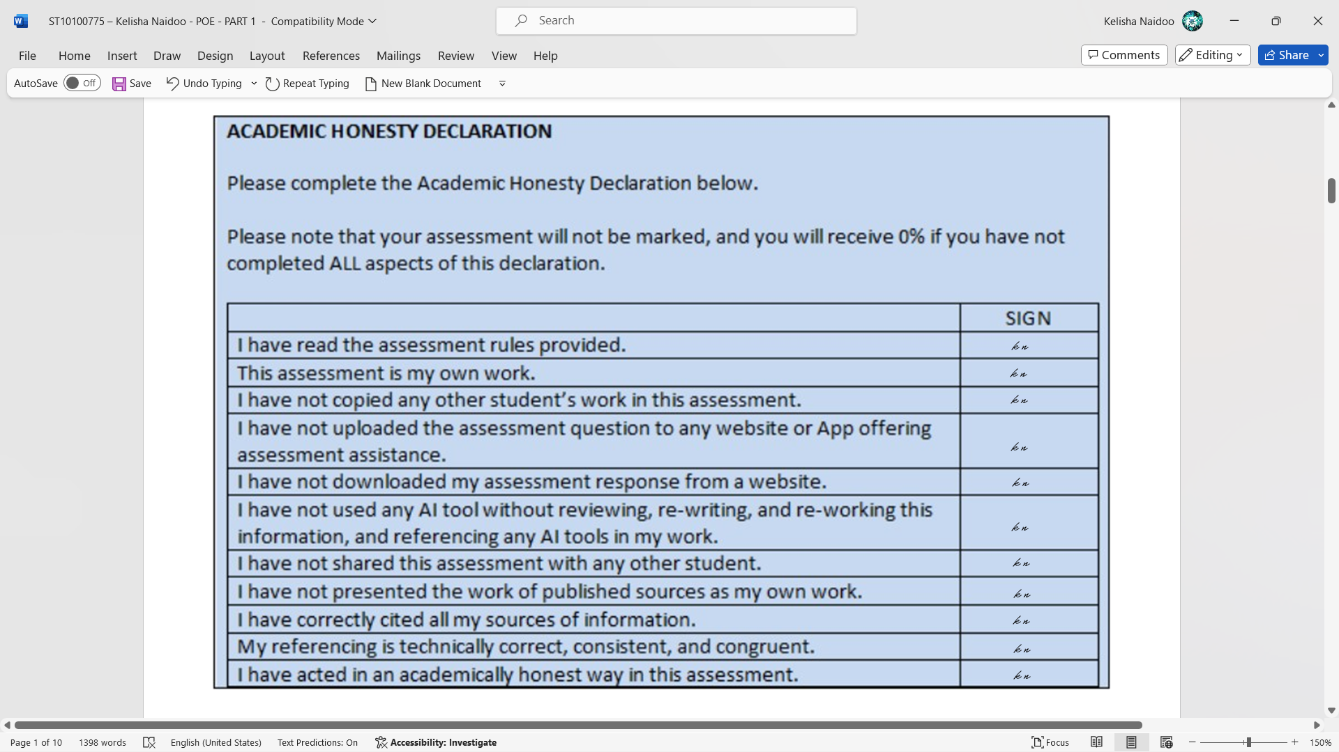

Table of Contents

EXECUTIVE SUMMARY: 4

ANALYSIS OF NON-FUNCTIONAL REQUIREMENTS: 4

Scalability 4

Security 4

Usability 4

Performance 5

ANALYSIS OF FUNCTIONAL REQUIREMENTS: 5

User Registration and Authentication 5

Profile Management 5

Sustainable Farming Hub 5

Educational Resources 5

Real-time Data Sharing and Collaboration 5

Security and Privacy measures 5

ROLE OF DESIGN AND ARCHITECTURE PATTERNS 6

Relevance: 6

Integration: 6

Justification: 6

DIAGRAM SHOWING THE CONNECTED PLATFORM LAYERS AND COMPONENTS 7

THE AGRI-ENERGY CONNECT PLATFORM LAYERS AND COMPONENTS: 8

User Interfaces: 8

Security Layer: 8

Microservices: 8

API Gateway: 8

Database Layer: 8

External Integrations: 8

Content Delivery Network (CDN): 8

CONCLUSION 8

References 9

Revolutionizing Agriculture: A Comprehensive Proposal for the Agri-Energy Connect Platform Development

Prepared by: Web Wise Solutions

## EXECUTIVE SUMMARY:

The application that was outsourced to our company is a digital platform called “Agri-Energy Connect” this platform will be used for collaborative purposes between farmers, employees, green energy experts, and enthusiasts. The purpose of this platform is to promote more environmentally friendly energy usage and sustainable agriculture. In this proposal we will be outlining the visions, objectives, a full explanation on a high-level plan for the platform, and the non-functional requirements of this project. The last part that will be discussed is the architectural patterns that will be used to ensure that the platform is working effectively and efficiently. (Malsam, 2023)

## ANALYSIS OF NON-FUNCTIONAL REQUIREMENTS:

A non-functional requirement refers to characteristics or qualities which explain the performance and process of the system. Some of the non-functional requirements are scalability, security, usability, and performance. Non- functional focuses on the quality, constraints, and attributes which will impact the whole system. (Framework, 2023)

### Scalability

This platform will be handling an ever-increasing number of users and the amount of data on the platform, to accommodate for this we can use microservice architecture where we can leverage from the infrastructure of the integrated cloud-based system. By using these we can plan for future grow scaling and the allocating of the resources in an efficient manner.

### Security

One of the many concerns in this digitalised society is the security of the sensitive user data and the financial transactions. This is why we have a few security measures that are vital to ensure the security of this sensitive data. Some of these security measures are the industry standard protocols, HTTPS, encryptions, multi-factor authentication methods. Another way to counter this security issue is having frequent security audits and testing the firewall which will protect against any cyber threats/attacks on the system.

### Usability

One of the main necessities for this platform is the accessibilities for the different users, it should be accessible on different devices and the system needs to be intuitive. The design principles will be centered around the user to ensure they have a full user experience, even after the launch of the application the user testing and feedback will be collected and analysed to improve the interface in the following updates to add a more personalised touch to the features and this helps to improve the user’s experience.

### Performance

The platform needs to be able to handle real time data sharing and collaborative systems, the system will need to have a high backend system performance to allow the real time sharing. The database queries will be enhanced and use mechanisms like cache, and it will have integrated content delivery networks, this will reduce the latency of the system. There will be systems in place to monitor performance and conduct load testing to see if the system can handle the heavy usage.

## ANALYSIS OF FUNCTIONAL REQUIREMENTS:

The Agri-Energy Connect platform has functional requirements which ensure that the user experience fulfils the purpose of the collaboration between agriculture and energy. (Contributor, 2018)

### User Registration and Authentication

For secure access the user can create a personalized account for a successfully safe login. If the user successfully logs in, then they will be able to use their specified roles while on the platform.

### Profile Management

Allowing users to customize their experience by uploading personal details on the profile or by sharing information about their expertise. The system will ensure that the experience is filtered according to the user’s preferences and interests.

### Sustainable Farming Hub

Provides resources and forums for sustainable practices this also includes being able to browse or filter the resources, some examples of this are the organic farming methods or water conservation methods. The other features are discussion boards which allow uses to seek advise and to share any experiences relating to the specific resource categories.

### Educational Resources

Offers courses and educational materials including, online courses, workshops, all of these will ensure that they integrate the energy and agricultural methods to have sustainable farming to produce better results.

### Real-time Data Sharing and Collaboration

Users can collaborate and host fund raises to finance sustainable farming initiatives, the platform should be compatible with real time data sharing which allows communication with other users.

### Security and Privacy measures

To protect user data and transactions the platform should have encryption, access controls and data anonymization techniques. With these measures in place, it will prevent any unauthorised access or any data breaches.

## ROLE OF DESIGN AND ARCHITECTURE PATTERNS

### Relevance:

The design and architectural patterns are especially important to consider due to ensuring the correct one is used. We need to consider the scalability, maintenance, and the extensibility of Agri-Energy Connects software system.

### Integration:

The best choice for this web application platforms architecture is the Model-View-Controller (MVC), this architectural design allows for future reusability of the code which makes it easier to perform updates on the system. This type of architecture allows us to utilize the repository pattern data access, it also allows us to have components which will interact with the data using more simplified interfaces, this helps with cost effectiveness as it allows us to have the data stored and accessed in a less specific way, making the system more flexible and easier to adapt to any changes or to maintain. (Kaalel, 2024)

### Justification:

These patterns will ensure the code stays organised, this way its much easier to work with/read, and for clear view for future changes. These enable a smooth integration of any updated features, improved developments, and with these the platform will allow for a long-term development.

## DIAGRAM SHOWING THE CONNECTED PLATFORM LAYERS AND COMPONENTS

## THE AGRI-ENERGY CONNECT PLATFORM LAYERS AND COMPONENTS:

### User Interfaces:

Interfaces accessible through web browsers and mobile devices, designed for intuitive interaction by farmers, green energy experts, and enthusiasts.

### Security Layer:

Encompasses measures like HTTPS encryption, authentication mechanisms, access controls, and security audits to safeguard user data and interactions.

### Microservices:

Independently deployable services handling specific functionalities such as user management, forum moderation, and product listings, enabling scalability and easier maintenance.

### API Gateway:

Central entry point for external clients to interact with platform microservices, managing routing, authentication, and load balancing for a unified interface.

### Database Layer:

Multiple databases storing different types of data, including user profiles, forum discussions, product listings, project details, and transaction records, utilizing relational and NoSQL databases.

### External Integrations:

Integrations with external systems like green energy providers, government databases, weather APIs, and financial institutions enrich platform functionalities and provide valuable resources.

### Content Delivery Network (CDN):

Improves platform performance and reliability by caching static assets and delivering them from geographically distributed servers, reducing latency for users accessing the platform from various regions.

## CONCLUSION

The Agri-Energy Connect platform is a pioneering effort to merge agriculture and renewable energy in a digital space. Emphasizing scalability, security, usability, and performance, and drawing on design and architecture patterns, we're poised to deliver a resilient and efficient solution. We eagerly anticipate the chance to realize this vision and contribute significantly to sustainable farming and green energy adoption.

Thank you for considering our company’s proposal.

Web Wise Solutions

# References

Contributor, T. T. 2018. *Functional Requirements, May 2018*. [Online]. Available at: https://www.techtarget.com/whatis/definition/functional-requirements [Accessed 3 April 2024]

Framework, S. A. 2023. *Nonfunctional Requirements, 13 October 2023*. [Online]. Available at: https://scaledagileframework.com/nonfunctional-requirements/ [Accessed 26 March 2024]

Kaalel. 2024. *MVC Framework Introduction, 16 April 2024*. [Online]. Available at: https://www.geeksforgeeks.org/mvc-framework-introduction/ [Accessed 31 March 2024]

Malsam, W. 2023. *How to Write an Executive Summary, 21 July 2023*. [Online]. Available at: https://www.projectmanager.com/blog/write-an-executive-summary [Accessed 10 April 2024]